
AIN SHAMS UNIVERSITY
FACULTY OF ENGINEERING
CSE241 Object-Oriented Programming
HOTEL RESERVATION SYSTEM
Milestone 1
Project Report
Instructors:
Prof. Mahmoud Khalil
Eng. Mazen Tarek

Prepared by:
Hazem Hassan Sayed (25P0125)
Mariam Sameh Sadek (25P0396)
Rovan Nour Rashwan (23P0388)
Khaled Ahmed Mohamed (25P0408)
Date: 26/4/2026

1. Introduction
The objective of this project is to design and implement a comprehensive desktop-based system for managing hotel reservations. The system facilitates interactions between three primary users: Guests, Receptionists, and Admins. It addresses the need for a centralized platform to manage room availability, handle secure user registrations, process bookings, and maintain an organized database of amenities and room types.

2. System Overview
The system is built using core Object-Oriented Programming principles to ensure scalability and maintainability.
2.1 OOP Principles Applied
- Encapsulation: All model classes ( Guest, Staff, Room. etc) use private fields with public getters and setters to protect data integrity.
- Inheritance: A common Staff parent class is used to derive Admin and Reception subclasses, sharing attributes like username and password while allowing for specialized behaviors.
- Polymorphism: The system identifies staff roles at login using the instanceof operator to provide role-specific dashboards
- Abstraction: The Staff class is defined as abstract, ensuring that only specific roles (Admin/Receptionist) can be instantiated.

2.2 Core Classes and Models
- Guest: Handles user registration, login, and preferences. It includes validation logic for age (minimum 21 years) and unique usernames.

- Staff (Admin & Reception): Admin: Possesses full CRUD (Create, Read, Update, Delete) permissions for rooms, amenities, and room types ,
Receptionist: Manages the check-in and check-out processes for guests.

- Room & RoomType: Models the physical rooms and their categories (Single, Double, Suite).

- Amenity: Represents individual services like Wi-Fi, TV, and Mini-bar.

- Database: Acts as the application's in-memory data store using static ArrayList fields to maintain persistence during the application's lifecycle.

3. Validation & Exceptions

3.1 Validation Logic
The system implements robust validation to ensure data quality:
- Age Restriction: Both Guests and Staff must be born in 2005 or earlier (minimum 21 years old).
- Unique Usernames: The system checks the Database during registration to prevent duplicate usernames for both staff and guests.
- Secure Passwords: Guest passwords must be at least 8 characters long and include uppercase, lowercase, numbers, and special characters

3.2 In-Memory Database
The Database class is pre-populated with dummy data (e.g., Staff: Saif and Ellie; Guests: Ahmed and Sara) to allow for immediate testing and demonstration.

3.3 Exception Handling
Custom exceptions, such as RoomNotAvailableException and InvalidPaymentException, are defined to handle specific business logic errors gracefully.

4. UML Class Diagram
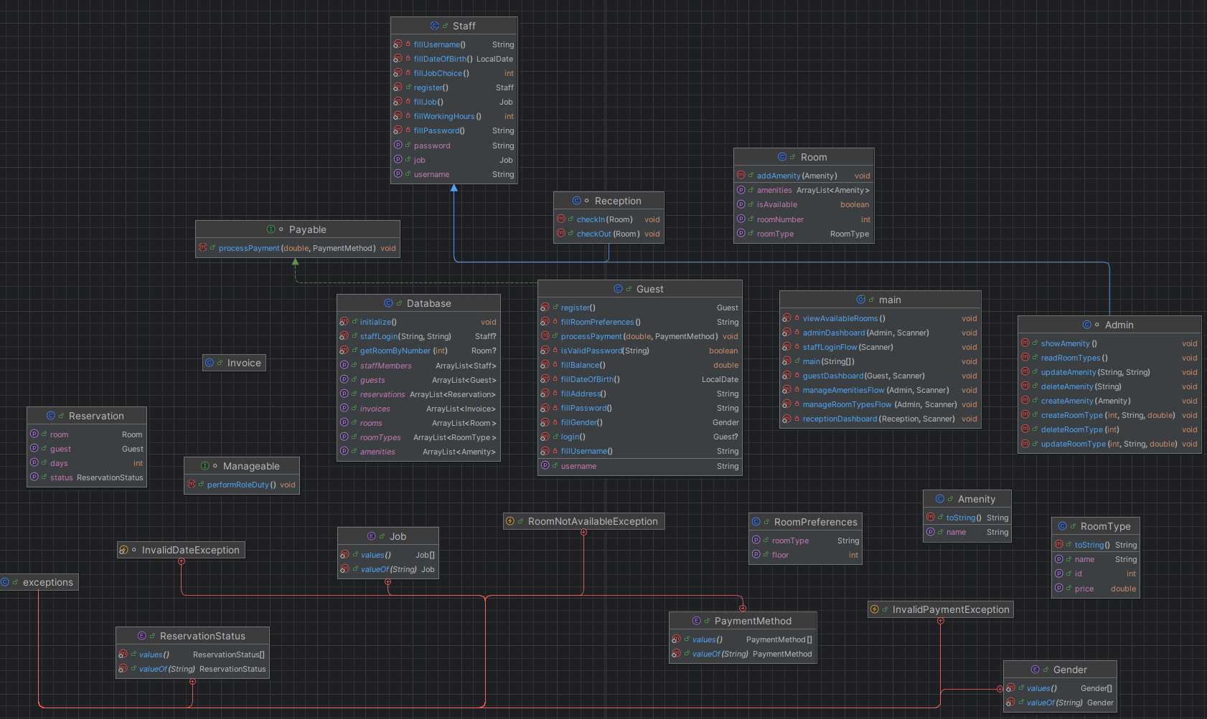
5. Limitations
- Persistence: Since the system uses an in-memory database, data is lost once the application is closed.
- User Interface: The system currently operates via a command-line interface and doesn’t have a user interface.

6. Sample Output
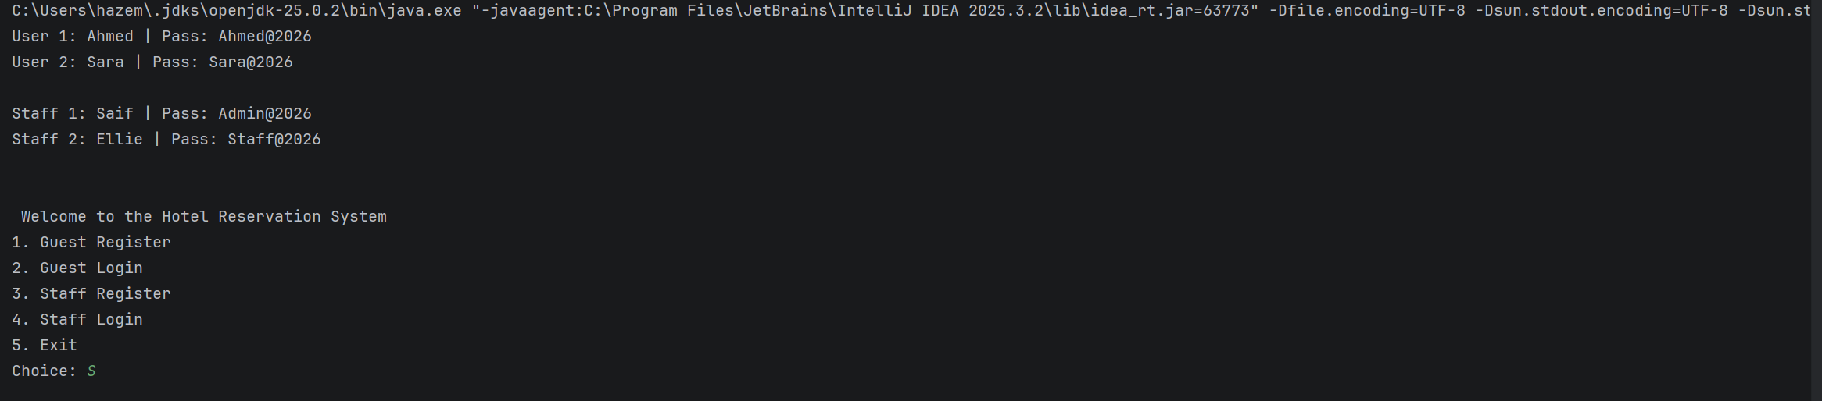

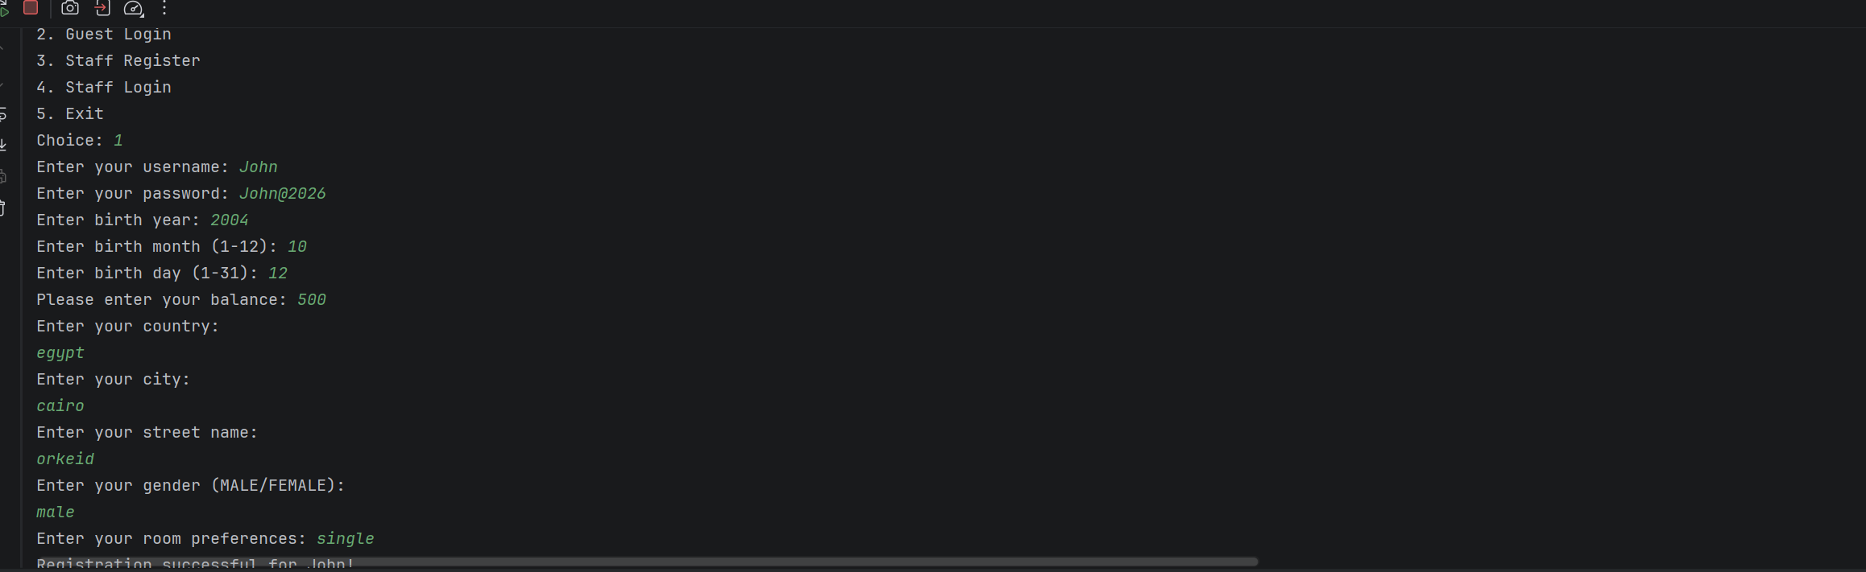

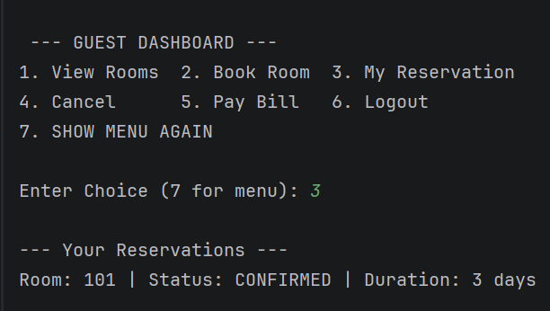

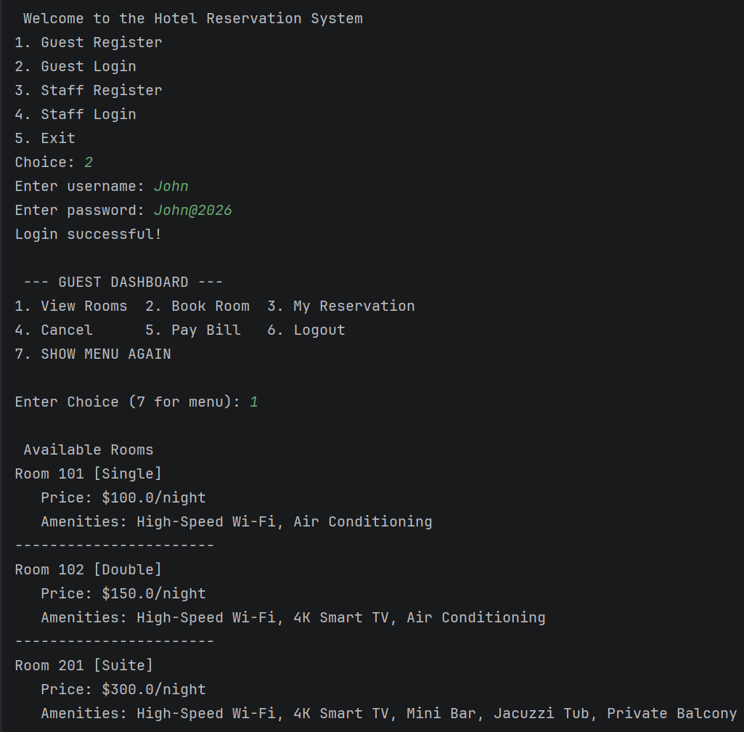

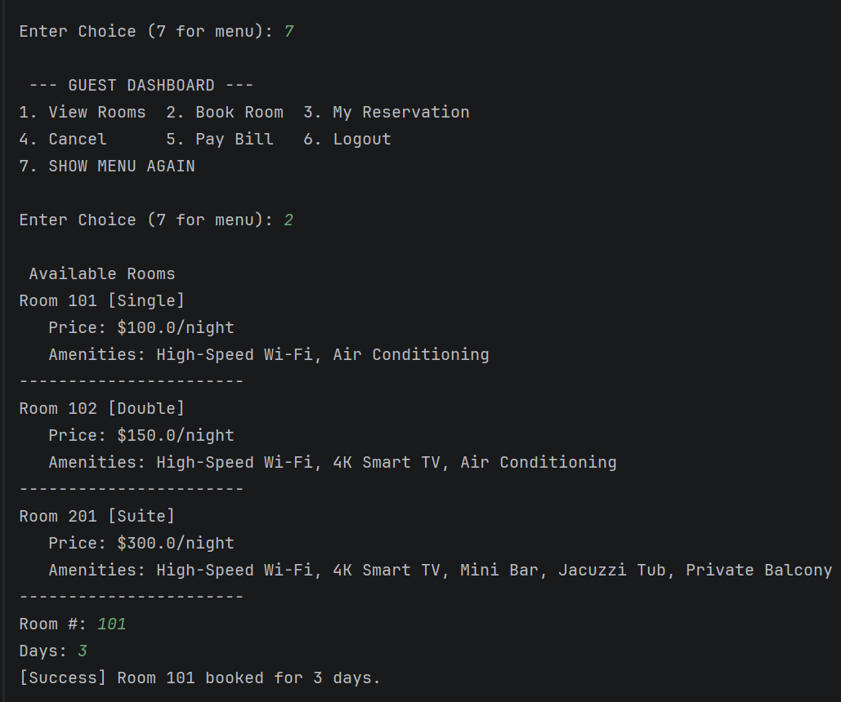

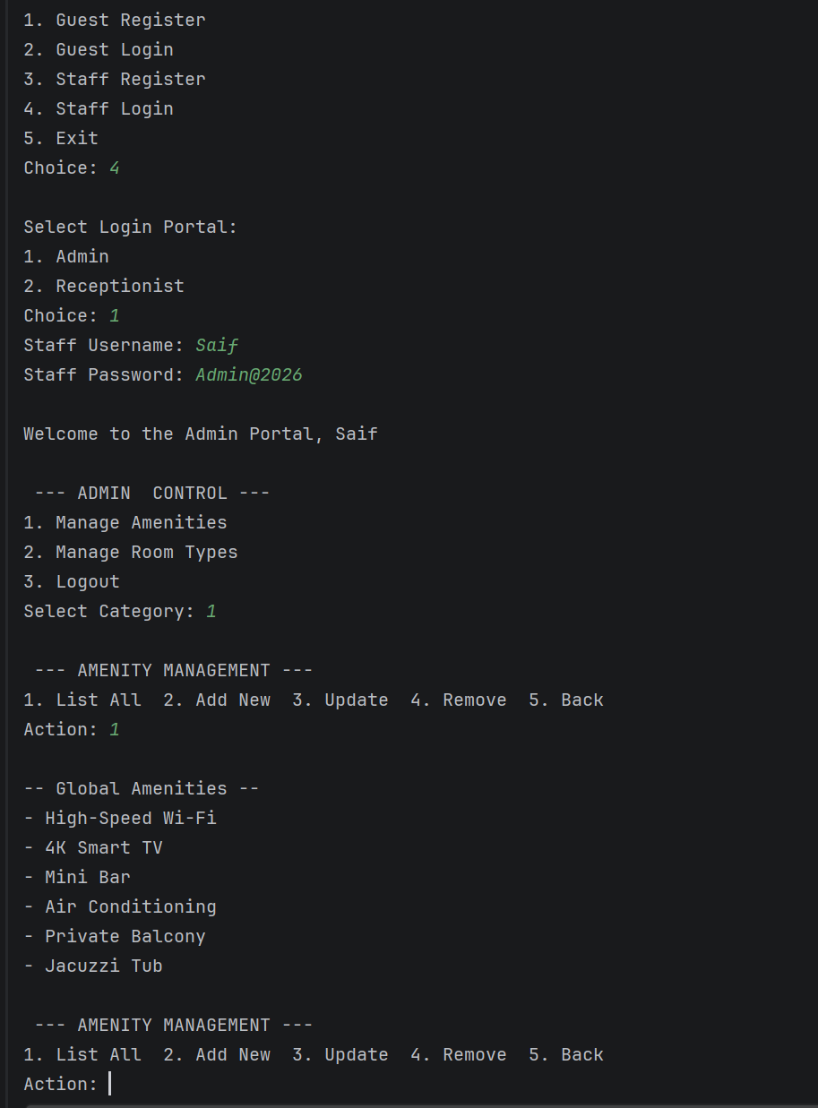

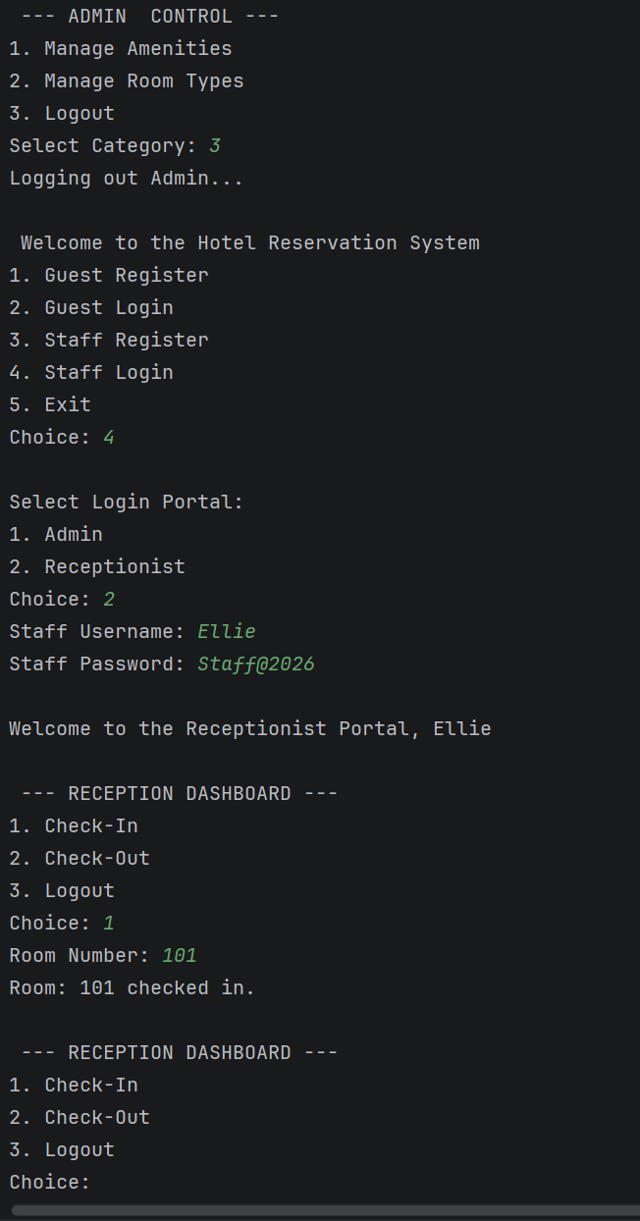

7. Design Decisions
- Role Selection at Login: We decided to implement a role-selection prompt during the staff login flow. This adds a layer of security by verifying that the user is attempting to access the portal corresponding to their specific Staff type (e.g., an Admin cannot log into the Receptionist portal).
- Date Management: We utilized the java.time.LocalDate API for birth dates to handle leap years and date comparisons.

8. Team Contributions
Hazem : Database Class, code integration , main initialization and code testing
Mariam : Guest and Staff classes
Rovan : Reservation and invoice classes
Khaled : Room ,Roomtypes and Amenities Classes

9. References
- Daniel Liang, Introduction to Java Programming, 10th Edition, Pearson, 5 2014.
- Java Documentations

